mFourfit (Paul Brown and David Rand)
Overview and Theory:
Here we assume that the data can be modelled by the sum of a constant offset term plus (up to) five sine and five cosine waves associated with some, unknown, period. Rather than trying to estimate the period we specify an upper and a lower boundary for the period and then iterate for each period within those limits in increments of 0.01 hour. We then see which period “best” fits the available data.
So for each period τ we state that an approximation to the data series can be generated according to the model:
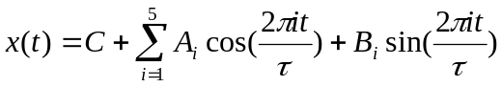
This gives us a total of 11 parameters to estimate for each period. The parameters are then estimated by using ordinary least squares covariance.
Having determined the parameters for each period, the corresponding theoretical time series, x(t) can be generated for each period and the sum of squares difference (SS) calculated between the theoretical time series and the real data.
It may be that not all 11 terms are required in the model, and that those components which do not have a significant weighting can be removed. A non-significant component is (roughly) defined as being one where half the amplitude of the weighting is made up of noise/uncertainty.
Once the non-significant terms have been removed a new theoretical time series is generated and the sum of squares of that time series is calculated. The likelihood of that fit is then calculated according to the formula:
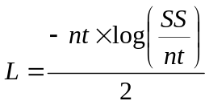
In this case a smaller, i.e. less negative, value indicates a better fit. The Akaike information criterion is also calculated, as AIC = 2k – 2ln(L), where k is the number of (significant) parameters in the model. This describes the trade-off between the accuracy and complexity of the model and can be used to compare different models. In this case models are generated for each period τ and the one with the smallest AIC is the best fit.

Initial data interpolation and detrending:
Data are read in from the input file and any missing data (indicated by the value -1.0) are calculated using linear interpolation.
Amplitude detrending is then carried out as follows: local regression is carried out to remove any baseline trend, and the resulting amplitudes are calculated. Local linear regression is then carried out on these amplitudes to remove the trend in amplitude and finally the baseline trend is added back on.
We are carrying out locally linear regression, i.e. locally fitting a line through the observations in the neighbourhood rather than a constant across all observations. We also use a weighting function so that the weighting/emphasis is smaller as we get observations that are further away from the point where we are fitting the linear regression. Our weighting function, or kernel, is a normal distribution with the weighting controlled by the variance, which in this context is known as the bandwidth. If no bandwidth is specified the default value is 10.
So we are fitting a local polynomial of order p with kernel weighting K, this can be written as:
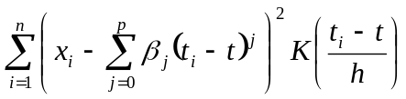
In our case we are using a polynomial of order 1 (aka a linear fit) and our kernel is a normal distribution with zero mean and standard deviation = bandwidth. The objective is to find the values of β_{j} which minimize the above function. This can be re-written as
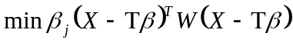
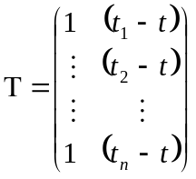
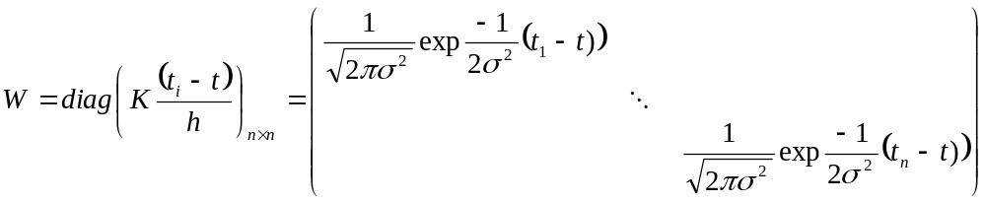
The weights β which minimize this are given by:
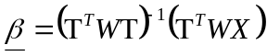
Here X are our observations and t_{i} are the times of the observations.
So first we carry out local linear regression (as described above) to determine the baseline trend. This is then subtracted, pointwise, from the data and the amplitudes of the detrended data calculated. Local linear regression (as described above) is then carried out on the amplitudes and the amplitude trend removed (by division/normalization rather than subtraction). The result is then multiplied by the mean of the amplitude trend line and finally the baseline trend is added back on. This gives data which has had the trend in amplitude removed but whose baseline follows the experimental data.
Next baseline detrending is carried out. For this local linear regression is carried out to determine the baseline trend. This is then subtracted, pointwise, from the data. The mean of the baseline trend is then calculated and this is added back on to the data.
(And no I’m not sure what the point is of removing the baseline, calculating and removing the amplitude, and the adding the baseline back on, only to re-remove the baseline!)
Pseudo code:

id = input_data;
it = input_times;
m = find(id == -1);%remove placeholders fo rmissig data
id(m) = [];
it(m) = [];
input_data = interp1(it, id, input_times, 'linear', 'extrap');
input_data(find(input_data < 0)) = 0;

if dtra > 0
input_data = detrend_amp(input_data, input_times);
end
if dtrb > 0
input_data = detrend_base(input_data, input_times);
end
real_data = cell(1, size(input_data,1));
for i = 1:size(input_data, 1)
real_data{i} = input_data(i);
end
for i = 1:size(m, 1)
real_data{m(i)} = {' '};
end

local regression function:
use pre-specified bandwidth
else bandwidth = 10

n=length(data_col); set up and initialise matrices and
b=zeros(n,2); vectors required for regression
te=zeros(2,1);
ov=ones(n,1);
ones_times=[ov times]; This is the matrix T, above
wcoeff=(1/(2*pi*bandwidth^2))^0.5; Weighting coefficient
hv=2*bandwidth^2;
for i=1:n
w(:,i)=wcoeff*exp(-(times-times(i)).^2/hv); Diag elements of W
end
for i=1:n
W=diag(w(i,:));
te=ones_times'*W; te=T^{T}W
b(i,:)=(inv(te*ones_times)*(te*data_col))'; b=(T^{T}WT)⁻¹(T^{T}WX)
end
fv=b(:,1)+b(:,2).*times;

amplitude detrending function
fv1 = local_regression(times, data_col); baseline trend
x=data_col-fv1; baseline trend removed
y=abs(x);
i=sign(x);
R=local_regression(times, y);amplitude trend
mR=mean(R);
z=y./R; remove trend in amplitude point by point
z=(z.*i); reconstruct original sign of z
z=mR*z+fv1; multiply b amp trend, add baseline back

baseline detrending function
fv1 = local_regression(times, data_col); baseline trend
x = data_col-fv1; baseline trend removed
z = x + mean(fv1); mean of baseline trend added back on

Identifying best fit period and model:
The minimum and maximum periods allowed for the data are then identified and a model for each period, in increments of 0.01 hours, is calculated as follows: Our model is:
This can be written in matrix form as X = A b where
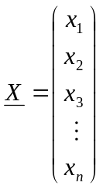
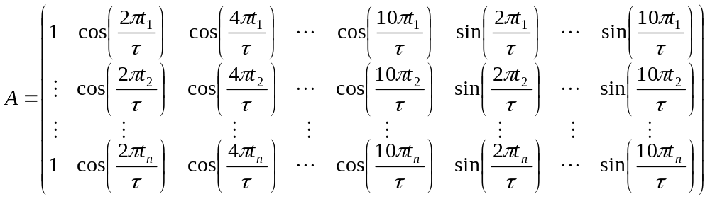
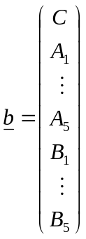
So we want the ordinary least squares solution to this linear system of equations X=Ab which is given by:
b= (A^{T}A)⁻¹A^{T}X
We also want to know the variance of the estimated weights. This can be determined either by calculating (A^{T}A)⁻¹ explicitly or, if we use a subroutine/object which calculates S, the estimated covariance matrix of X, and also calculates the mean square error then we can divide the estimated covariance matrix S by the mean square error (mse).
We then calculate the theoretical fit for that period according to:
using our estimates for C, A_{i} and B_{i} and calculate the associated sum of squares for this fit which we then weight by the number of time points to give a variable sig.
We can then take the diagonal of the ols variance matrix (which gives us an estimate of the standard errors of the weights), multiply it by sig and take the square root. This effectively gives us the estimated standard errors on the parameters. Then any parameter which is less than twice its standard error (as just calculated) is set to zero (cos effectively it is just noise).

Having removed any “junk” parameters re-calculate the theoretical fit, then recalculate the associated sum of squares, sig and the likelihood. We also then use this (new) likelihood to calculate the AIC and store it.

After all the periods have been tested and all the AICs calculated we select the one with the smallest value and make a note of the corresponding period and time series.

Pseudo-code:

for per = 1:num_periods
waves = zeros(num_times,num_components);matrix A
for co = 1:6
for tm = 1:num_times
waves(tm,co) = cos(2*pi*t(tm)*(co-1)/periods(per));
end
end
for co=7:num_components
for tm = 1:num_times
waves(tm,co) = sin(2*pi*t(tm)*(co-nct)/periods(per));
end
end Matrix A now populated

coeffs = zeros(num_components,1);
ols_var = zeros(num_components,num_components);
[coeffs stdx mse S] = lscov(waves, expt_data);matlab fn, stdx not used
ols_var = S./mse;

theoretical_fit(:,per) = waves*coeffs; best model with that period

ss = sum((expt_data-theoretical_fit(:,per)).^2);sum of squares for this model
sig(per) = ss/num_times; error for this model weighted for num timepoints
bv = diag(sig(per)*ols_var).^0.5;%diagonal of ols variance matrix. each value multiplied by sig and square rooted. Or square root of covariance weighted by total error and normalized by number of data points

nb = coeffs./bv; %weight coefficients according to goodness of fit
isig = (abs(nb) > 2); %note any component with value <= 2
sig_components(:,per) = isig.*coeffs;discard small components
theoretical_fit1(:,per) = waves*sig_components(:,per);%create improved theoretical fit

ss1 = sum((expt_data-theoretical_fit1(:,per)).^2);%sum of squares for this fit
sig1(per) = ss1/num_times;%error for this fit weighted for num timepoints
lik1(per) = -0.5*num_times*log(sig1(per));%likelihood of this fit being correct
aic1(per) = lik1(per) - sum(isig);%AIC associated with this fit
end

[mv, best] = max(aic1);
best_period = periods(bestbest_time_series = theoretical_fit1(:,best);%corresponding time series values
best_components = sig_components(:,best);%cos and sin components of best fit

Interpolation and peak finding of best fit model:

First we find the sum of squares of the differences between the best model and the experimental data.

We then generate a time series where we add the trends in amplitude and baseline from the real data to the theoretical data. More precisely:

Calculate the baseline of the experimental data by carrying out local linear regression on the experimental data.

Calculate the amplitude trend of the experimental data by carrying out local linear regression on the absolute value of the experimental data (with the baseline subtracted) and double the amplitude trend.

Now subtract the mean of the theoretical data from the theoretical data (to give zero mean data) and then normalize the theoretical data so that it has unity amplitude (by dividing the theoretical data by the maximum amplitude of that data)

Then do point-wise multiplication of the theoretical data by the amplitude trend of the experimental data and finally add the experimental data baseline to the theoretical data.

Now we can find the sum of squares of the differences between this new theoretical model and the experimental data and compare this to the sum of squares generated from our original theoretical model. Whichever model gives the smaller sum of squares is the one we will take forward.

Use the sum of squares for this (best) model and divide it by the number of time points. Then, as before calculate the likelihood and the associated AIC, but this time we do not penalize the AIC by taking into account the number of components. So the AIC is just the likelihood – this is ok because we are only reporting it rather than using it to make a decision.

Now we do some interpolation. The original data were samples taken at 2 hourly intervals. We now interpolate the (best) theoretical time series to generate data at 10 minute intervals. The interpolation can be either a cubic spline, a polynomial fit or a linear fit. In practice the cubic spline fit is used to give a smooth curve through all the interpolated time points.

Now we can step through the interpolated data looking for the first peak. As we are only looking for the first peak we examine the data-points in an interval from the start to just short of two periods (to allow for the fact that, as with a cosine with no offset, the peak might be right at the beginning or the end of a period. So we capture the theoretical values corresponding to the data points. We then calculate the rate of change between one data-point and the next across our data of interest. Then we try and identify and consecutive data points where the gradient changes from positive or zero at one point and negative at the next as this would be consistent with a peak. Having identified any peaks we then find the amplitude of the peak, the width of the peak (which we estimate by calculating the second derivative), and the time at which the peak occurs. NB we put a logic check in here such that we only search the second day’s (period’s) data if no peak has been found in the first day.

We might then want to do some checking to confirm that any “peaks” we have found are indeed peaks rather than just shoulders, but at the moment the algorithm doesn’t bother to check this.

Having located the first peak we now scan through the data for the first day/period and identify the largest and smallest amplitude data-points. If these are both greater than zero we can calculate the “fold-change” simply by dividing the max by the min.

Pseudo-code:
ss = sum((expt_data-best_time_series).^2);%sum of squares between best model and experimental data
%add trend if it gives a better fit
baseTrend = local_regression(times, expt_data);%see pseudo-code above, calculates trend in real data
ampTrend=2*local_regression(times, abs(expt_data-baseTrend));%see pseudo-code above calculates trend in amp

r = theor_data - mean(theor_data);% normalise data to give zero mean and amplitude 1
r = r./max(r);
r = r.*ampTrend;%apply trend in amp (multiplicatively)
r = r + baseTrend;%add baseline trend to theoretical data
%Now sum of squares for new fit (with trend line). Now check to see if this improves matters: and if so, keep new time series.
temp_ss = sum((expt_data-temp_time_series).^2);
if temp_ss < ss
ss = temp_ss
best_time_series = temp_time_series;
end

sig = ss/num_times;%error for this fit weighted for num timepoints
lik = -0.5*num_times*log(sig);%likelihood for this fit
np = sum(abs(best_components)>0);%number of elements that are non-zero
aic = lik;%here only use likelihood so we can report it

new_times = [times(1):1/6:times(end)]; %point every 10 min
best_time_series = spline(times, best_time_series, new_times);

%find first peak(s)
last = times(1) + best_period;
one_cycle = find(new_times < (last*2));
if one_cycle(end) < size(best_time_series,2)
one_cycle = best_time_series(1:one_cycle(end)+1);
else
one_cycle = best_time_series(1:end);
end

peaktimes = [];
%find gradients from rate of change
dydt = zeros(1,size(one_cycle,2)-1);
for i = 1:size(dydt,2)
dydt(i) = one_cycle(i+1) - one_cycle(i);
end

for i = 3:size(dydt,2)-2
if dydt(i) < 0 & dydt(i-1) >= 0 %-
%derivative going from positive to negative through zero means a peak
%save [time size sharpness]
psize = one_cycle(i);
pwidth = abs((dydt(i)-dydt(i-1))/(new_times(i) - new_times(i-1)));%second derivative at peak is an estimate
%high value = sharp peak
peaktimes = [peaktimes; new_times(i) psize, pwidth];
end
if new_times(i) >= last & ~isempty(peaktimes)
break;%only go into second day if no peaks in first, possibly due to shortening tau
end
end
one_cycle = find(new_times < last);
if one_cycle(end) < size(best_time_series,2)
one_cycle = best_time_series(1:one_cycle(end)+1);
else
one_cycle = best_time_series(1:end);
end
if min(one_cycle) > 0
amp = max(one_cycle) / min(one_cycle); %fold change
else
amp = ' ';
end

Data output:

Finally we output all the data in the following format:

Theoretical data 1 to n; time points 1 to n
Amplitude, period, AIC. Then for each peak output the phase (i.e. phase-offset) of the peak, the peak size and the peak sharpness.

Pseudo code:
ts = cell(1, 2 + 2 * size(new_times,2));
for i = 1:size(new_times,2)
ts{1, i+1} = best_time_series(i);
ts{1, size(new_times,2) + 2 + i} = new_times(i);
end
ts{1,1} = 'Theoretical Data';
ts{1, size(new_times,2) + 2} = 'Times';

per = best_period;
if ~isempty(peaktimes)
peaktimes = sortrows(peaktimes,2);%sort on size
ph = peaktimes;
ph = flipud(ph);%row vector
ph = ph';
else
ph=' ';
end
file=fopen(strcat(filename,'.out'),'w');
fprintf(file,'AMPLITUDE,%f\n',amp);
fprintf(file,'PERIOD,%f\n',per);
fprintf(file,'AIC,%f\n',aic);
for i = 1:(size(ph,2))
fprintf(file,'<<<PPS>>>\n');
fprintf(file,'PHASE,%f\n',ph(1,i));
fprintf(file,'PEAKSIZE,%f\n',ph(2,i));
fprintf(file,'SHARPNESS,%f\n',ph(3,i));
fprintf(file,'<<<ENDPPS>>>\n');
end
fprintf(file,'<<<THEE>>>\n');
for i = 1:size(new_times,2)
fprintf(file,'THEE,%f,%f\n',best_time_series(i),new_times(i));
end
fprintf(file,'<<<ENDTHEE>>>\n');
fclose(file);

